#1 Our Friends the Pharisees

- Tony & Cherie Blair – is it a fair representation?
  - Elements of truth maybe, but way out of proportion.
  - Caricatures: exaggerate bad points – laugh at them – irrelevant – ignore.
- Person next to you - Pharisees: what do you think of?
  - Words: brood of vipers – whitewashed tombs
    - What do we mean if we call someone a Pharisee?
  - Attitudes:
    - Pride: love most important seats in synagogues – thank you not like other men - pompous - vain
    - Love attention: greetings in the market places - “Rabbi” – fasting: disfigured faces.
    - Hypocrisy: Jesus: these people honour me with their lips but their hearts are far from me.
    - Tithing: Give 10% of garden herbs but neglect justice
    - Sabbath: obsessed
  - Wanted to kill Jesus
- All that is a caricature. Truth in there for sure. But not full picture.
  - A Team – box set – rubbish – goodies & baddies.
    - Caricatures. When 12 – explosions - ok.
    - Older: character development – makes them tick – thoughts – motivations – aspirations.
  - When we think of P as baddies of the Bible – helps us ignore them.
    - Want us to see today: P are our friends – if /very careful: us.

Truth about P
- Profile:
  - If gospels – movie. Star: J. Supporting actors: disciples? No.
  - Show book
- People of the Book
  - Determined to live righteous lives based on the Bible.
  - One occasion (Luke 10:25-28): P -> J. How inherit eternal life? Good qn.
    - J: What does the Law say? Gives brilliant answer:
    - Love the Lord your God with all your heart and with all your soul and with all your strength and with all your mind’; and, ‘Love your neighbour as yourself.
    - Yes, perfect answer says J – 100% - go to top of the class.
  - Loved the Word – knew it inside out – studied it – memorised it – wanted to understand it accurately – taught it to children. Today: high view of scripture.
    - /liberals – evangelicals of their day – fundamentalists
  - Just as we read and preach the Bible, so did they. Small groups for Bible study – so did they. 1-2-1 – so did they. Their view of scripture was essentially the same as ours.

- Lived out faith.
  - /Academic study – learning by rote.
    - Interpreted the OT to apply to modern life. Very best of motives: bring every area of life under the teaching of scripture.
  - Wanted to bring understanding to the masses, /elite.
    - Pharisees ran the synagogues – local churches – so everyone could hear and understand God’s word for themselves.
  - Jesus: Unless you are more righteous than the Pharisees, you won’t enter the Kingdom of heaven.
    - J point: affirming these were very righteous ppl – gold-standard.
    - Not enough to be good – need J.
  - Word “Pharisee”: “separated one”. Bit like if you were known as “Holy Joe” or “Jesus freak”. /mind – embraced being different. Just like we do.

- Pure worship
  - Temple was corrupt. /P – Priests, Levites, elite. J: turned over tables.
  - Part of the reason for local synagogues – avoid corruption of T.
    - If you liked ritual -> Temple
    - If you loved God -> Synagogue
  - A bit like – Reformation – RC corrupt – some stood up against it. That was the P.

- Prayer & fasting
  - Prayed in public - motivations weren’t good – liked to be seen by others – but /argue with their courage. How many of us would pray out loud on a street corner?
    - So important: must do it. More committed to regular prayer than most of us.
  - And they fasted regularly - how many of us do that – sermon series. Way more committed than us.

- Fellowship
  - Committed to each other – small groups – ate at each others’ houses – v hospitable.
  - 3 times in Luke’s gospel – J invited to home of a Pharisee. Sometimes tried to trip him up
    - Look another way: how many of us regularly invite ppl to our homes for a meal and chat. Never mind those we know we will probably disagree with!
  - V hospitable – kind – generous ppl. Great model for us to follow.

- Giving
  - Committed to 10% of earnings - of everything.
  - Inc herb garden – everything they owned.
    - Most of us nowhere near that generous. How much do you give, citizen of 4th wealthiest country in the world?

- Evangelism
  - J: travel over land and sea to win a single convert.
  - P won over many Romans with their passionate, active evangelism.

- Politics
  - Fairly uninterested in politics except if it directly clashed with their faith.
    - Culture war: living in a liberal permissive society – Romans & Greeks around them: v liberal attitudes – their job to stand up to it – make a stand for truth, holiness – traditional values: marriage, family, morality, respect.
  - Most were hard-working middle-class businessmen. /Professional religious leaders. Owned shops, small businesses.
  - If they were alive today, they’d be hard-working middle-England.

Who do these ppl remind you of?
- Makes a huge difference when reading gospels.
- Reading story – who do you automatically relate to? Only 4 major characters:
  - Jesus – relate to him best – issues!
  - Disciples – actually fairly minor role in gospels – until receive HS – hardly do/say anything.
    - Peter: gets some good stories, John gets a few – James gets a line or two – Thomas and Judas likewise.
    - Mostly they’re portrayed as arguing quite a lot, /understanding most of the time. Until HS comes along – power comes!
  - “Sinners” – probably most of us think of relating to the bad ppl in the stories. Jesus is the hero – we are the spiritually bankrupt. Lot of truth there. Maybe some here: had a life characterised by terrible sin before coming to X.
    - Woman at well: 5 broken marriages & now given up on marriage and living with some guy.
    - Zaccaheus: lying, cheating, corrupt official
    - But for most of us – Xn family – nice home – car – job – kids.
  - Who are we meant to relate to in the stories??? Pharisees!
    - Much more like most of us than the “sinners”. We need to get to know the P. Like us!
  - Imagine: no mirrors in house. What would you look like?
    - Some: same!
    - Most: unaware hair is all over place – zit – make-up.
    - Eventually might convince yourself you look OK – no way of knowing truth.
  - P: like a spiritual mirror to us. Show us condition of our hearts. They are so like us in so many ways – the things J warns them of, we need to be warned of.

Matthew 21:28-32
- Jesus is talking to religious ppl – P. How know?
  - v45 – tell us – got very angry – wanted J arrested b/c they knew the stories he was telling were about them.
- Story goes like this: man with 2 sons. Tells both: Son, work-day today – go and do an honest days’ labour in the family vineyard.
  - 2 sons – 2 reactions.
    - #1 – no, /be bothered. But then changes his mind and goes works hard all day.
    - #2 - sure, I’ll go – but then goes back to bed.
  - Which did the right thing?
    - Obv answer: the one who actually did the work.
    - Point: Actions speak louder than words. True, we agree, right?
- Then J applies that principle:
Jesus said to them, “Truly I tell you, the tax collectors and the prostitutes are entering the kingdom of God ahead of you. v32 For John came to you to show you the way of righteousness, and you did not believe him, but the tax collectors and the prostitutes did. And even after you saw this, you did not repent and believe him.
- IOW:
  - Tax collectors – prostitutes – “sinners” – like #1 son - no fine words – no-one expected them to do the right thing. But here they were – flocking to Jesus in repentance and faith. Lives transformed in the power of God.
  - P: like #2 son – lots of fine-sounding words – yes of course we’ll go and work hard today – but they failed to do the right thing. They ignored JtB and they were ignoring J.
- Qn: who do you relate to in the story?
  - Maybe someone here does genuinely relate to “sinners” know ur life: mess – done terrible things.
    - Come to J – warm welcome – wants to forgive you through cross - give you a new start.
  - Problem: most of us immediately relate to the “sinners” when the Pharisees are a much closer match for us!
    - We think: “stupid proud Pharisees – didn’t enter the Kingdom of God b/c didn’t repent – couldn’t see their own blindness”
    - We are the humble repentant sinners - distance ourselves from P even though our b/g is much more like them.
    - Miss point! Hold up mirror.
- Maybe – what if – what happens – if we put ourselves in the place of the Pharisees in the story? What is J msg to us then?
  - How easy it is to assume we’re part of the kingdom when we’re not. The P’s thought they were OK – but far from it.
    - Jesus is speaking to people who love the Bible – good people – kind – hospitable – generous - say all the right things. But in the end /part of the Kingdom. Hear me?
    - Jesus is speaking to people like many of us: lived good lives - /terrible ones. Often done the right thing. /part of K.
    - Fine words – learning the right answers – learning how to behave. /part of K.
    - So easy for this to happen. So does your life look different? Sorry for your sin? Repenting every day? Trusting J – not just in word but in action?
  - Pharisees had a form of godliness but denied its power.
    - Form of godliness – looked v good on outside – hearts far from Him.
    - Knew the ritual - /God
    - Knew the right words - /Spirit
    - Initially enthusiastic – “yes, I’ll go” - failed to follow-up with life-transforming action b/c no life-transforming Sp there - /power. Got power of God?
  - The Pharisees loved the Bible – good people – thought they were OK – trying their best. And failed to enter the Kingdom of God. So easy. That ought to shake us.

2Corinthians 13:5 Examine yourselves to see whether you are in the faith; test yourselves.
- Everyone: /long – position
- Am I trusting J – today?
- Repenting of sin – today?
- In step w Spirit - today?

Pr: Thx – mirror – P – like us in so many ways – failed to enter in. Expose hearts – no illusions – no deception – in: assurance. Not: repentance & faith.

Quiet.

Discussion questions

There were lots of different political and religious groups around at the time of Jesus. This activity has two parts:

Q1: Somehow the names and descriptions below have become muddled up. Can you fix them? Look up the references as you go along. After each description, the number of mentions in the gospels is recorded. Eg. The Sanhedrin is mentioned by name 4 times in the gospels.

Sanhedrin (4) | On the political left, King Herod’s fanboys, who himself was a puppet of the Roman empire. The tax-collectors would have fallen into this group. Eg. Mark 3:6
Elders of the people (25) | A militant far-right group, committed to liberating Israel from Roman rule. Eg. Matthew 10:4
Chief priests (42) | A collection of 70 rulers who formed the Jewish government. At the time of Jesus, the Pharisees made up the largest and most powerful group, but the Chief priests were still “in charge”. They had a fair bit of power over day-to-day matters but were not allowed to execute anyone. Eg. Mark 14:55, John 18:31
Pharisees (82) | In charge of the running of the Temple. At the time of Jesus, corruption was rife in the whole Temple system. Eg. Matthew 21:12
Zealots (3) | Older men who represented a town or city in the Sanhedrin. Some of Jesus’ most vocal opponents. 1Samuel 16:4
Herodians (3) | The theological liberals of the day. They were much more interested in power and politics than their theological opponents the Pharisees. Eg Matthew 22:23, Acts 5:17
Sadducees (9) | Committed to studying and applying the OT scriptures. Very influential among the ordinary people, and the group Jesus interacts with most, by far.
Scribes / Teachers of the Law (58) | An unofficial title, perhaps the equivalent of deacons in our church today. Eg. Matthew 9:23, Mark 5:22, John 12:42
Synagogue Leaders (3) | Highly educated men responsible for producing copies of the OT Bible. Because they were so familiar with the Law, they were also called upon to teach and resolve disputes. Eg. Ezra 7:6; Matthew 5:20

Q2: Can you add the names to the chart?

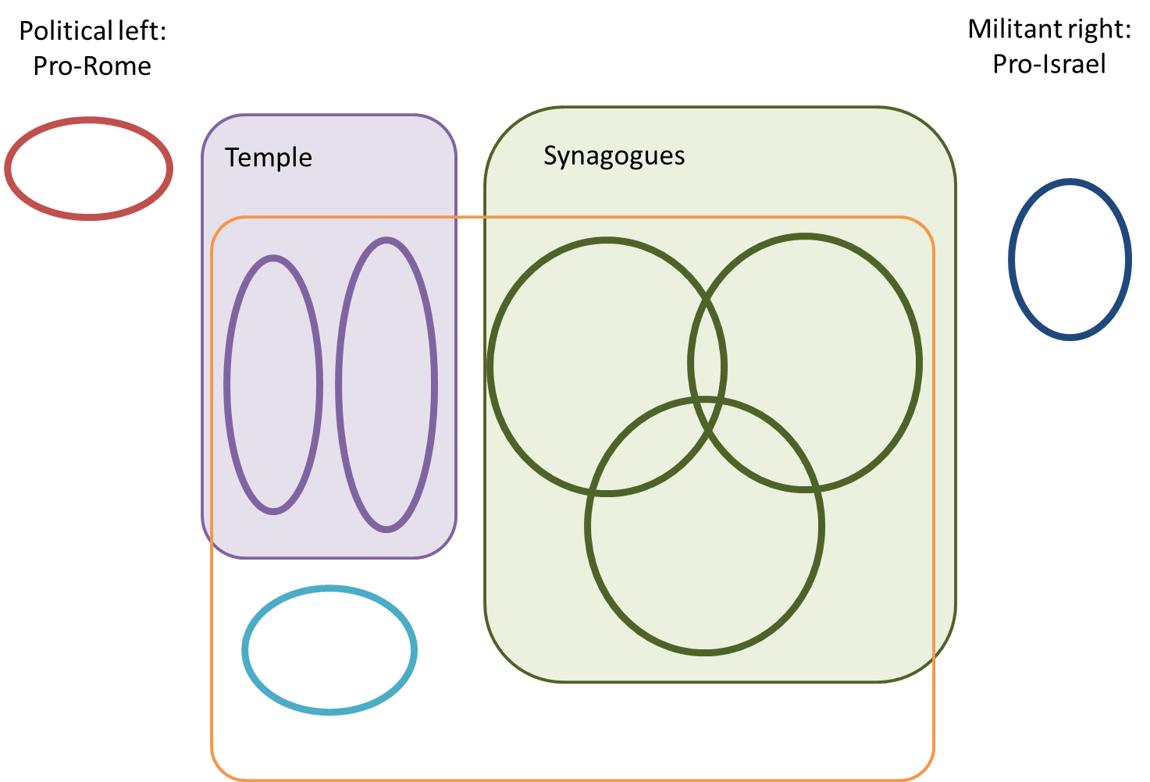

Q3. Out of all these groups, it’s notable that Jesus spends far more time interacting with the Pharisees than any other group. This is especially true if you add in the “Teachers of the Law” who had very similar beliefs. Why do you think Jesus interacts with them so much?

Q4. What was the majority view of the Pharisees about Jesus? Where did they go wrong? John 5:39-40.

Q5. Read John 12:42. How would it have felt to be “put out of the synagogue”? How does this make sense of Jesus’ statement in Matthew 23:13?

Q6. We saw on Sunday just how much we have in common with the Pharisees. Review that list. Can you add any more? Do any surprise you?

Q7. Paul was very happy to affirm the Pharisees’ beliefs (Acts 23:6-10) Jesus also affirmed the basics of the Pharisees beliefs: Read Matthew 23:2-3a but not 3b. What is Jesus saying? Why do you think we so quickly read on to v3b?

Q8. Not all the Pharisees were opposed to Jesus. We say on Sunday that at least 3 invited him round for a meal – a sign of kindness and generosity towards him. How do each of these other encounters change your view of them?
- Luke 5:17-26; Luke 13:31; John 3:1-2; John 7:45-52; John 9:16; John 19:38-39; Acts 15:5; Philippians 3:4-6
Discussion questions

There were lots of different political and religious groups around at the time of Jesus. This activity has two parts:

Q1: Somehow the names and descriptions below have become muddled up. Can you fix them? Look up the references as you go along. After each description, the number of mentions in the gospels is recorded. Eg. The Sanhedrin is mentioned by name 4 times in the gospels.

Sanhedrin (4) | A collection of 70 rulers who formed the Jewish government. At the time of Jesus, the Pharisees made up the largest and most powerful group, but the Chief priests were still “in charge”. They had a fair bit of power over day-to-day matters but were not allowed to execute anyone. Eg. Mark 14:55, John 18:31
Elders of the people (25) | Older men who represented a town or city in the Sanhedrin. Some of Jesus’ most vocal opponents. 1Samuel 16:4
Chief priests (42) | In charge of the running of the Temple. At the time of Jesus, corruption was rife in the whole Temple system. Eg. Matthew 21:12
Pharisees (82) | Committed to studying and applying the OT scriptures. Very influential among the ordinary people, and the group Jesus interacts with most, by far.
Zealots (3) | A militant far-right group, committed to liberating Israel from Roman rule. Eg. Matthew 10:4
Herodians (3) | On the political left, King Herod’s fanboys, who himself was a puppet of the Roman empire. The tax-collectors would have fallen into this group. Eg. Mark 3:6
Sadducees (9) | The theological liberals of the day. They were much more interested in power and politics than their theological opponents the Pharisees. Eg Matthew 22:23, Acts 5:17
Scribes / Teachers of the Law (58) | Highly educated men responsible for producing copies of the OT Bible. Because they were so familiar with the Law, they were also called upon to teach and resolve disputes. Eg. Ezra 7:6; Matthew 5:20
Synagogue Leaders (3) | An unofficial title, perhaps the equivalent of deacons in our church today. Eg. Matthew 9:23, Mark 5:22, John 12:42

Q2: Can you add the names to the chart?

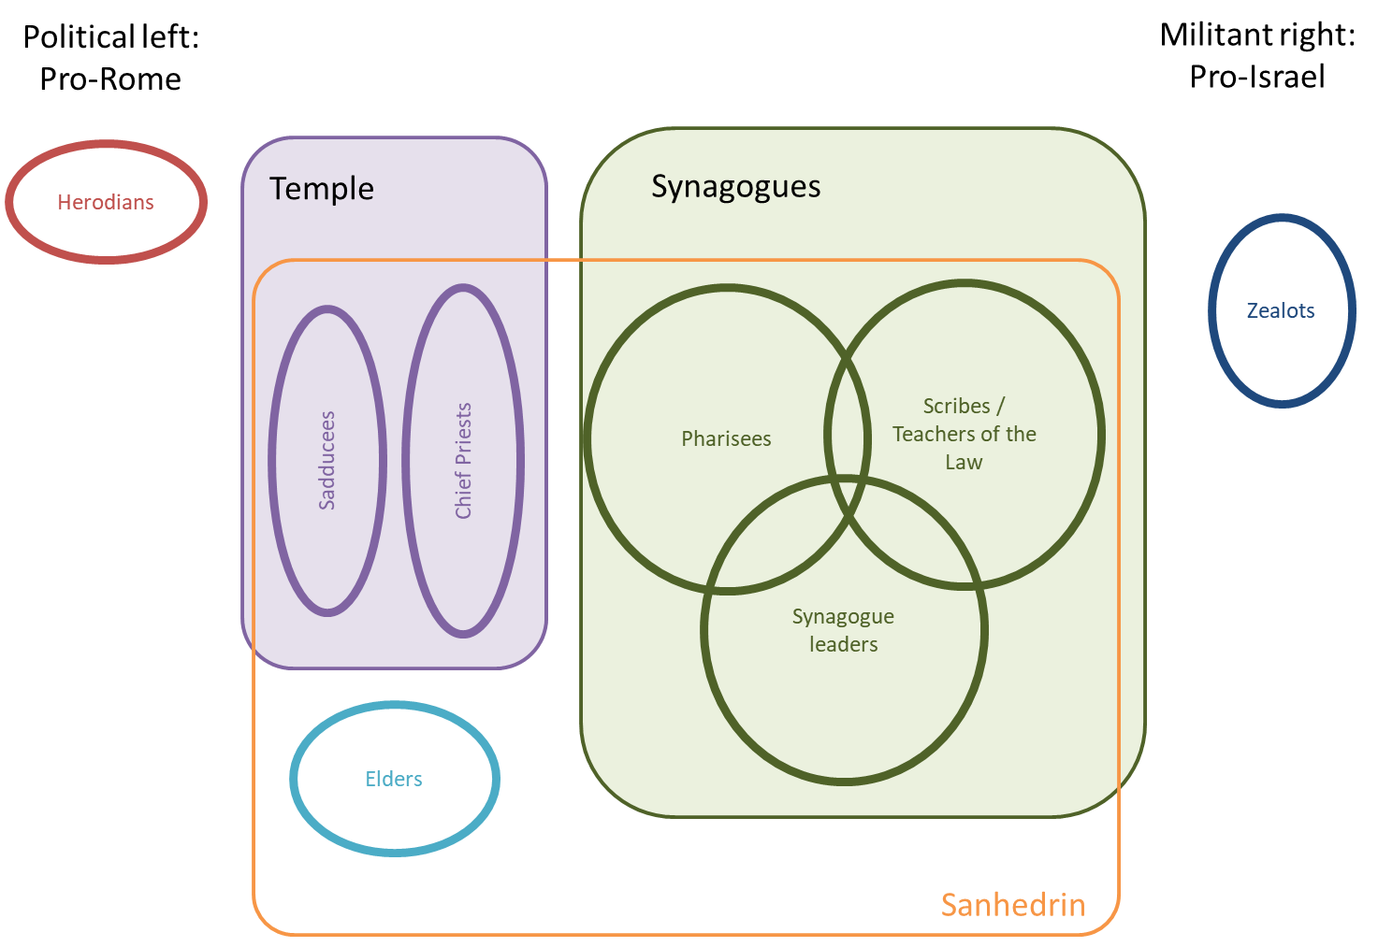

Q3. Out of all these groups, it’s notable that Jesus spends far more time interacting with the Pharisees than any other group. This is especially true if you add in the “Teachers of the Law” who had very similar beliefs. Why do you think Jesus interacts with them so much? Maybe because they were genuinely seeking God, but in the wrong way? He had little time for the politics of the other groups.

Q4. What was the majority view of the Pharisees about Jesus? Where did they go wrong? John 5:39-40. They refused to believe the scriptures that spoke about the Messiah – and therefore they refused to come to Jesus. They thought they were already right with God through their good works and law-keeping.

Q5. Read John 12:42. How would it have felt to be “put out of the synagogue”? How does this make sense of Jesus’ statement in Matthew 23:13? Similar to being removed from church membership – loss of friendship, reputation. Jesus is pretty strong in his condemnation of them here!

Q6. We saw on Sunday just how much we have in common with the Pharisees. Review that list. Can you add any more? Do any surprise you? People of the Book; Lived-out faith; Pure Worship; Prayer & fasting; Generous givers; Zealous evangelism; Committed to fellowship; Hard-working

Q7. Paul was very happy to affirm the Pharisees’ beliefs (Acts 23:6-10) Jesus also affirmed the basics of the Pharisees beliefs: Read Matthew 23:2-3a but not 3b. What is Jesus saying? Why do you think we so quickly read on to v3b? Jesus is clearly affirming the basic teaching of the Pharisees. They had a lot right. What they said was generally good. It was their actions that were the problem. We tend to skip over that to the condemnation in v3b because that fits our caricature better. We like to think of them as the enemy, not as our friends.

Q8. Not all the Pharisees were opposed to Jesus. We say on Sunday that at least 3 invited him round for a meal – a sign of kindness and generosity towards him. How do each of these other encounters change your view of them?
- Luke 5:17-26 Look who was there (v17) – and their response! (v26)
- Luke 13:31 If they believed Jesus was a blasphemer, they would not have warned him to escape!
- John 3:1-2 Note “we” – is Nic representing a group of curious Pharisees?
- John 7:45-52 Nic speaks up for Jesus and proves that their assertion that none of them had believed in Jesus was false.
- John 9:16 Some Pharisees stick up for Jesus.
- John 19:38-39 Joseph was a member of the Sanhedrin, possibly a Pharisee. Nic helps him deal with Jesus’ body.
- Acts 15:5 Some Pharisees became believers, but found their Jewish ways hard to reconcile to their new-found faith.
- Philippians 3:4-6 Paul was a senior Pharisee, trained by one of the greats!
Together they show us that the Pharisees were not a monolithic group opposed to Jesus. Some were curious, some followed, and one became the greatest theologian in history!

I’m pretty sure this is a picture of the Spitting Image puppets used around 1994.
Matthew 23:6
Luke 18:11
Luke 11:43
Matthew 23:7
Matthew 6:16
Matthew 15:8
Luke 11:42
Eg. Matthew 12:1-14
Loads of examples, but here’s one: Matthew 11:18
Matthew 5:20
Matthew 6:5
Luke 18:12
http://ceoworld.biz/2018/01/30/these-are-the-wealthiest-countries-in-the-world-us-china-japan-germany-india-2018/
2Timothy 3:5

